Are You Ready For Your Fire Inspection?

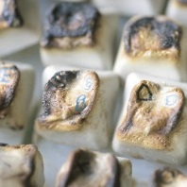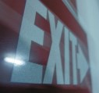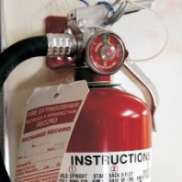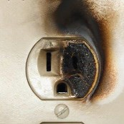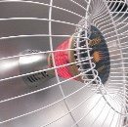
Top Ten Fire Code Violations
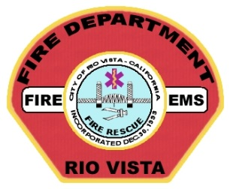
- Street address must be clearly marked and visible (in contrasting color) from the street fronting the property.

- Fire hydrants located on your property must be visible and accessible at all times, with three feet of clearance on all sides and no parking within 10 feet.

You have an upcoming Fire Safety Inspection scheduled with The Rio Vista Fire Department. During your Fire Inspection, we will evaluate the property for compliance with important fire and life safety regulations (exiting, fire alarms, fire extinguishers, electrical hazards, storage of combustibles, etc.).

This flyer identifies the top 10 deficiencies found during fire inspections. Please review this checklist and correct any potential deficiencies prior to your inspection; this will help you pass your inspection and
make your building safer year- round.

If you have questions about your upcoming inspection, please don't hesitate to call or stop by the Fire Station .

Rio Vista Fire Dept.
350 Main Street
Rio Vista CA 94571
707-374-2233
- Exit doors must open easily from the inside. Locking mechanisms on doors shall not require special knowledge or keys. The only exception is a main storefront door with a sign above that reads, “This door to remain unlocked when building is occupied.”

- Aisles, walkways, stairways, and paths leading to exits must be clear of storage and obstructions.

- Emergency lights and exit signs (that are lighted from within) must work properly and function in both normal and emergency power modes. Lighted exit signs must be lit at all times.

- Electrical outlets, junction boxes, and circuit breaker panels must be covered, and outlets and junction boxes must have the appropriate cover plate.

- Electrical extension cords cannot be used as a substitute for permanent wiring. Extension cords are only approved for “temporary use” (operating a vacuum cleaner, powering a tool while making a repair, etc.). Multi-outlet power strips, with built-in circuit breakers may be used to protect computers and related equipment.

- Fire extinguishers must be visible, readily accessible, mounted and serviced every 12 months.

- Fire sprinkler systems must be inspected regularly and tested every 5 years by a licensed fire protection contractor.

- Fire suppression systems for commercial cooking operations (hood systems) must be serviced and tested every 6 months by a licensed fire protection contractor.

